Case-based learning

Both of our undergraduate veterinary courses utilise case-based learning (CBL). This style of active, collaborative learning is student-led and is based on the problem-based learning educational strategy introduced at McMaster University in Canada in 1969. It supports students to develop clinical reasoning skills and problem solving alongside professional skills such as communication and teamwork. CBL utilises a seven-step methodology (see below), was rolled out in the University of Bristol’s flagship MB21 undergraduate medical programme in 2017 and has been adapted for use on the vet courses.

The seven steps

Within CBL students work through a case in small groups. Each case runs across a week, and includes two facilitated sessions, timetabled self/group study, and a case wrap up with a subject matter expert. Students are provided with the case information in advance of the first facilitated session (see example below), along with background information/resources. At the end of first session the intended learning outcomes are released (see example below). After an opportunity for self- and group study there is a second facilitated session, prior to which additional information may be released. At the end of the week all groups will come together for a wrap-up session with a subject matter expert to consolidate learning and clarify any remaining queries.

Case-based learning example

Case Information
You have just finished your weekly fertility visit to a regular client, Home Farm, and they mention that they have had two calves die this week. They ask you to examine another one which is looking sick.

Home Farm has a high yielding, Holstein-Friesian (HF), year-round calving herd, with 190 cows in milk. Calving takes place in a straw calving yard; calves are left on the dam for 24 hours and then separated and put in a barn. In the barn, there are 4 pens with around 15 calves per pen bedded on straw. The calves are fed milk replacer from a Wyedale milk feeder twice a day. Each pen has a water trough, hay rack and trough for creep feed. There are doors at either end of the barn which are kept open. There is Yorkshire boarding down the length of the barn and the roof space has been boarded up to be used as a space to store old equipment.

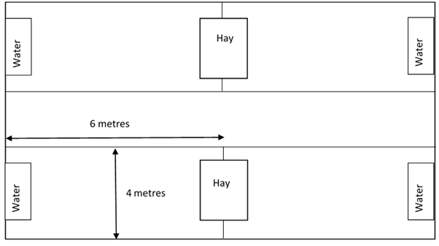

You examine the sick calf. The calf is two weeks old, it has a temperature of 39.8ºC, a heart rate of 120 beats per minute and a respiratory rate of 56 breaths per minute. It is reluctant to rise and is open-mouth breathing. You hear wheezing noises on auscultation of the chest, and lung noises are quiet cranioventrally. There is some mucopurulent nasal discharge. The calf is urinating and defecating normally.

You notice that when you enter the pen some of the other calves start coughing when disturbed. The farmer also mentions that some of his bulling heifers that are at pasture (which backs onto the barn) are also coughing.
You suspect pneumonia in the calves and lungworm in the older heifers; you collect some dung samples from the latter to confirm the diagnosis and discuss a plan for treating the affected groups with the farmer.
After a busy day you decide to go to the pub for tea with one of your colleagues. You're chatting about the outbreak of pneumonia and discussing the advice that you've given the farmer. As you're about to tuck into your food one of your clients, an organic farmer, Bob Chapman, catches your eye from an adjacent table and comes over to say hello. Bob buys beef cross calves and dairy bull calves from a few local dairy farms and sells them as stores at 13 months. He asks if you've just been discussing the outbreak of pneumonia at Home Farm. He was considering buying some calves from them but he had heard that they had had an outbreak of pneumonia.

Intended Learning Outcomes (ILOs)
These tell students what they need to learn/focus on whilst working through the case. Colour coding provides guidance to students regarding how much detail they need to go into, to answer/address each ILO
These ILOs will usually require a sentence or two to answer and/or will be more involved to research than blue ILOs, but less involved than green ILOs
These ILOs will usually require about a paragraph to answer and/or will take the longest time to research

Animal Management
Discuss options for housing of the young calf; individual vs group housing
Identify upper and lower critical temperatures for calves and recognise how calf jackets can be used
State the appropriate stocking density for calves in an indoor barn and suggest strategies that can be used to reduce stocking density

Welfare, Behaviour and Nutrition
Outline the requirements of the newborn calf and the importance of colostrum
Summarise nutritional requirements of calves up to weaning age
Appraise milk replacement feeding systems; replacer v whole milk, method of delivery, frequency and volume
Define growth rates of beef and dairy cattle

Cell Biology
State why ingestion of colostrum is important in calves and describe how to assess whether intake is adequate
Outline the main type of immunoglobulin found in colostrum
Outline the components of the innate immune system within the calves upper respiratory tract which help protect against respiratory tract infections
Explain the role of mucosa associated lymphoid tissue in the development of immunity to respiratory tract infections
Explain the effects of stress on the immune response

Agents of disease
Explain why there is a difference in the cause of an outbreak of coughing in older heifers compared to young calves
State the parasite that causes lungworm in cattle and describe the clinical signs, diagnosis, lifecycle and control of Dictyocaulus viviparus

Explain the role of the immune response in the presentation of disease related to D. viviparus in young and older cattle and naïve vs exposed cattle and how this affects control of the disease
Explain the role of vaccination in the control of disease related to D. viviparus
Outline the role of the inflammatory response to live and dead D. viviparus in the pathogenesis of disease

Pathology
Describe the gross appearance of lungs with pneumonia and explain why the changes result in disturbances of gas exchange

Professionalism
State the current price of a dairy calf and describe the economic effects of calf respiratory disease
Discuss how you would communicate your findings and recommendations to a farmer and discuss some of the challenges that are faced when implementing changes on farms
Explain your responsibilities regarding client confidentiality, discuss ways in which this may be breached unintentionally and how to avoid this happening

